Task 4 – Refactor with evidence
Baseline Evidence:
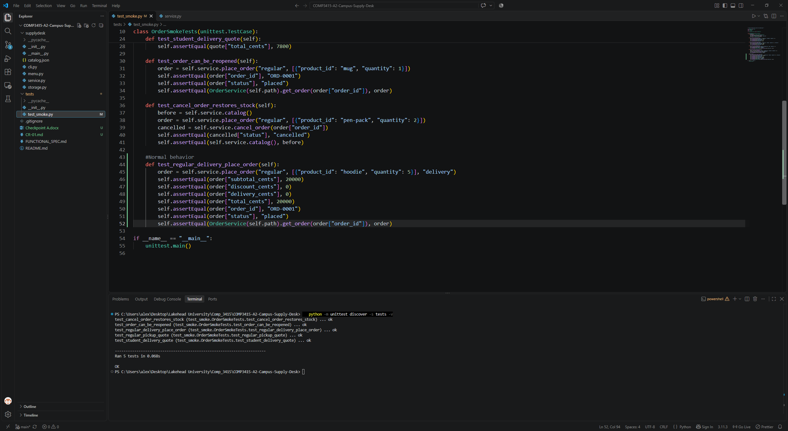
Discount didn’t applied
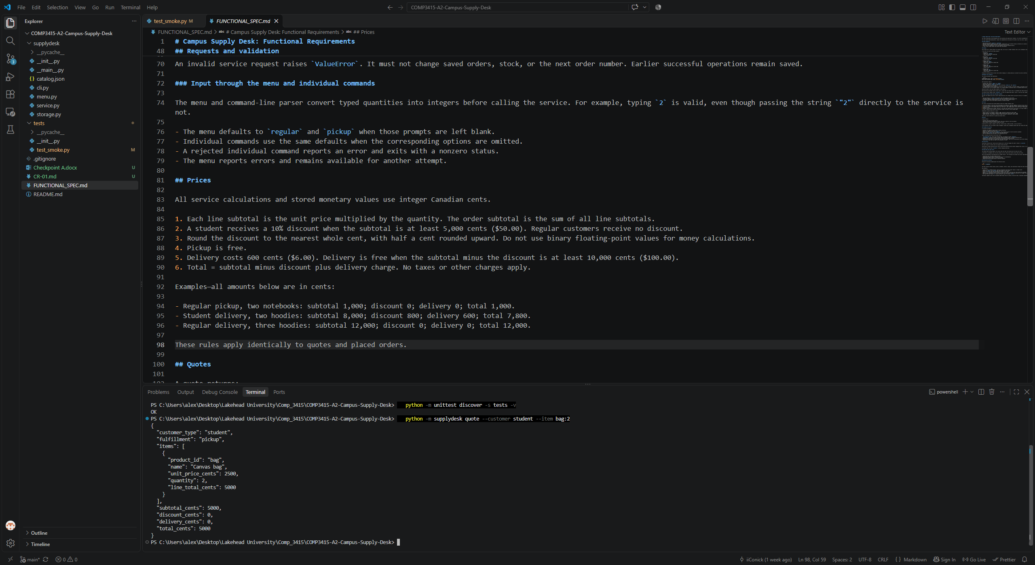
Added 18 test, three test intentionally failed.
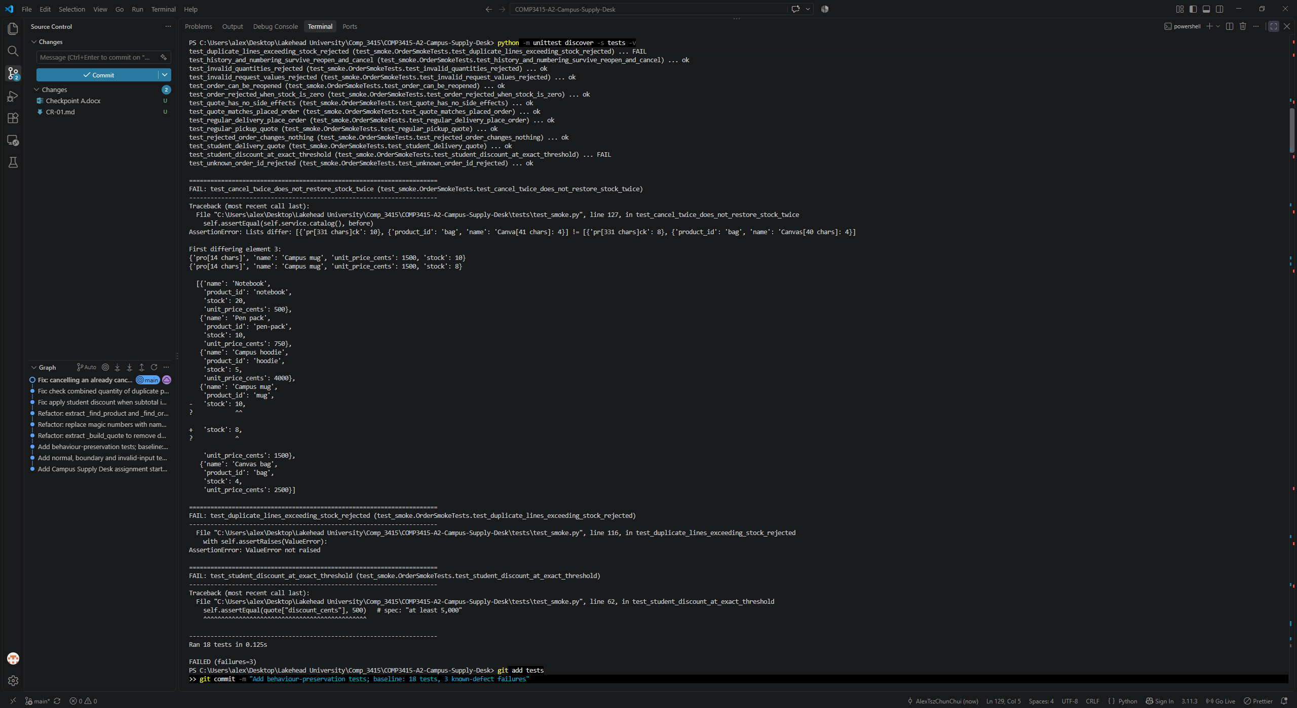
Refactoring the place_order and quote function.
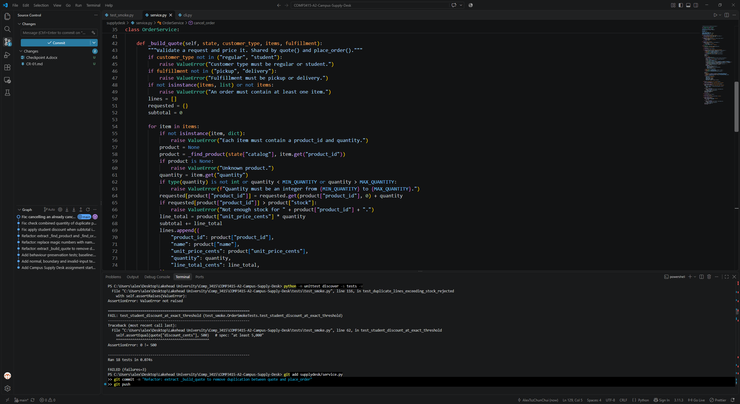
Refactoring magic_nubmer
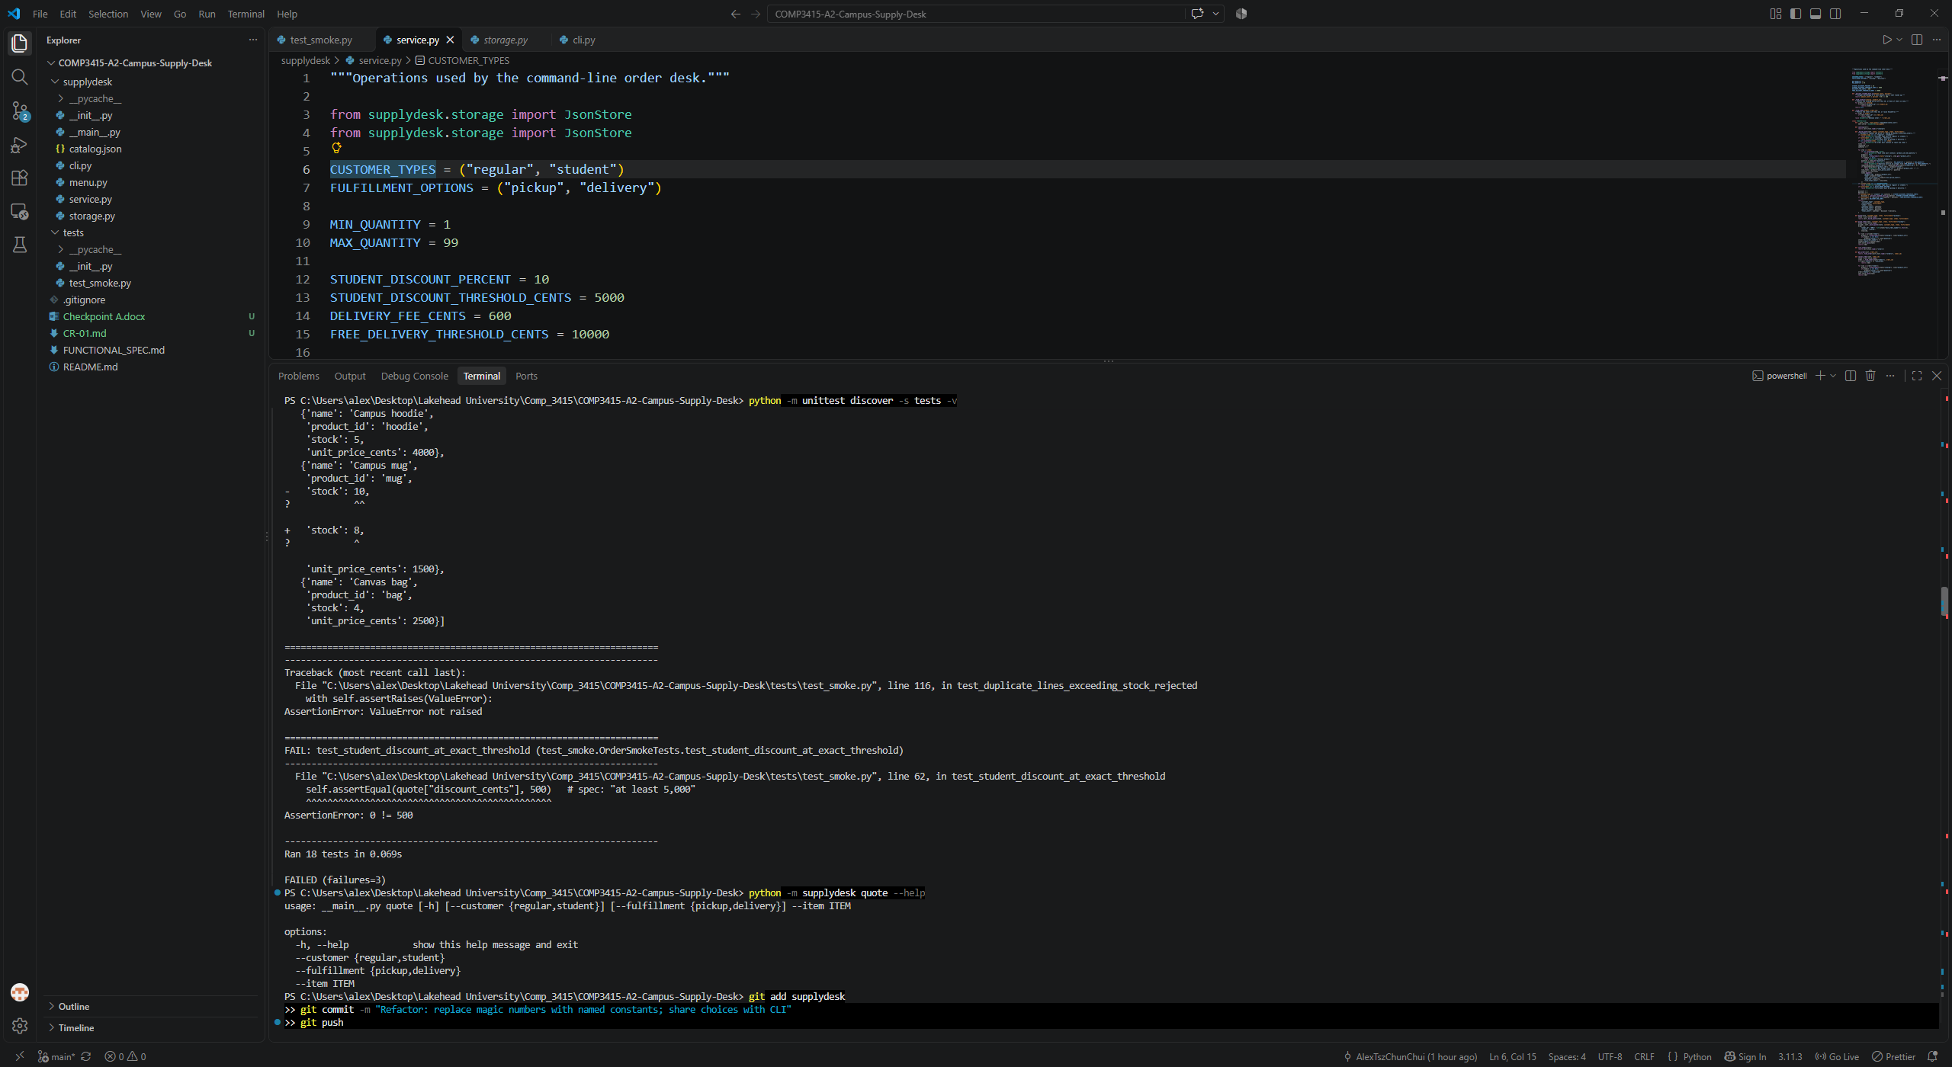

After refactoring, all defects is now fixed
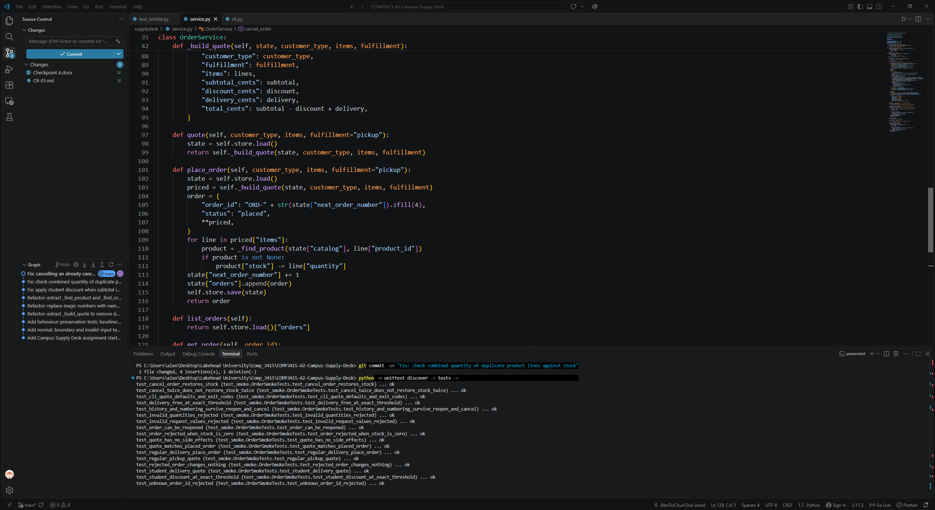

Before | Refactoring | Reason | After | Verification
There are a lot duplicate code or algorithm inside two function quote and place_order | We extract the main algorithm out into a function call build_quote. | Because duplicate code cost more in maintaining and is a potential failure if forgot to update the same algorithm in both method | Now both quote and place_order function call quote for getting the price sub_total, applied discount. The different is place_order have extra code to create the actual order and save it to the state | We run the 18 test, beside of the three that we intentionally to be failed, all others 15 should still pass.
We were using magic number for min and max quantity, student discount, and delivery cost | We create global variable for these value, and put them into the top of the file and also replace every magic number into variable | Because it is easier in maintaining, if customer asked to change discount percentage or how much to reach before applied discount, programmer don’t have to look into code and change those magic number. It also reduce the chance of missing some magic number and caused unexpected behaviour. | Customer types, fufillment options, min and max quantity, discount present, discount threshold, delivery fee, free delivery threshold are now extract from the algorithm. They are now global variable on the top of the file, and we can easily make any modification. | We run the 18 test, beside of the three that we intentionally to be failed, all others 15 should still pass.
3 potential defects of applying discount, Combined stock across duplicate product lines and cancel order return the order | We fix the algorithm so it now correctly applying discount for sub_total at least $50,00.  We now combine same product on multiple product line before validating the stock, so it won’t have by pass the stock limit.  We now have the function cancel order work as the SPEC document which Cancelling an already cancelled order returns the existing cancelled order without changing stock, prices, or history again. | Because this is a defect of our code, it does not working as what we want | Is not easier to understand or test or maintain but it help to ensure the application work as the SPEC requirements | We have 3 test that is specifically testing this 3 defects, including applying discount for $50.00 order, placing order with same item in multiple line to by pass the stock limit and checking if cancelling a cancelled order actually return that order. This 3 test was failed before we refactoring. But it now pass.

Task 5 – Client Change Request
- Which existing behaviour or requirement will change.
The named constant and the build_quote function will be change as there are now an extra option of fulfilment and it have a fixed cost.
The menu function will need to update to reflect this new option for user.
The other function should remain same as the requirements says that we have to preserve them to work as the same before adding new features.

- Service.py and menu.py will be change, cli.py might not need to change as we import the named variable from service.
- Beside of ensuring all the current test still passed, we have to added a new test to place an order about express delivery and ensure it work as expected.

Test result before adding features, most of the newly added test failed as the new feature have not yet be implemented.
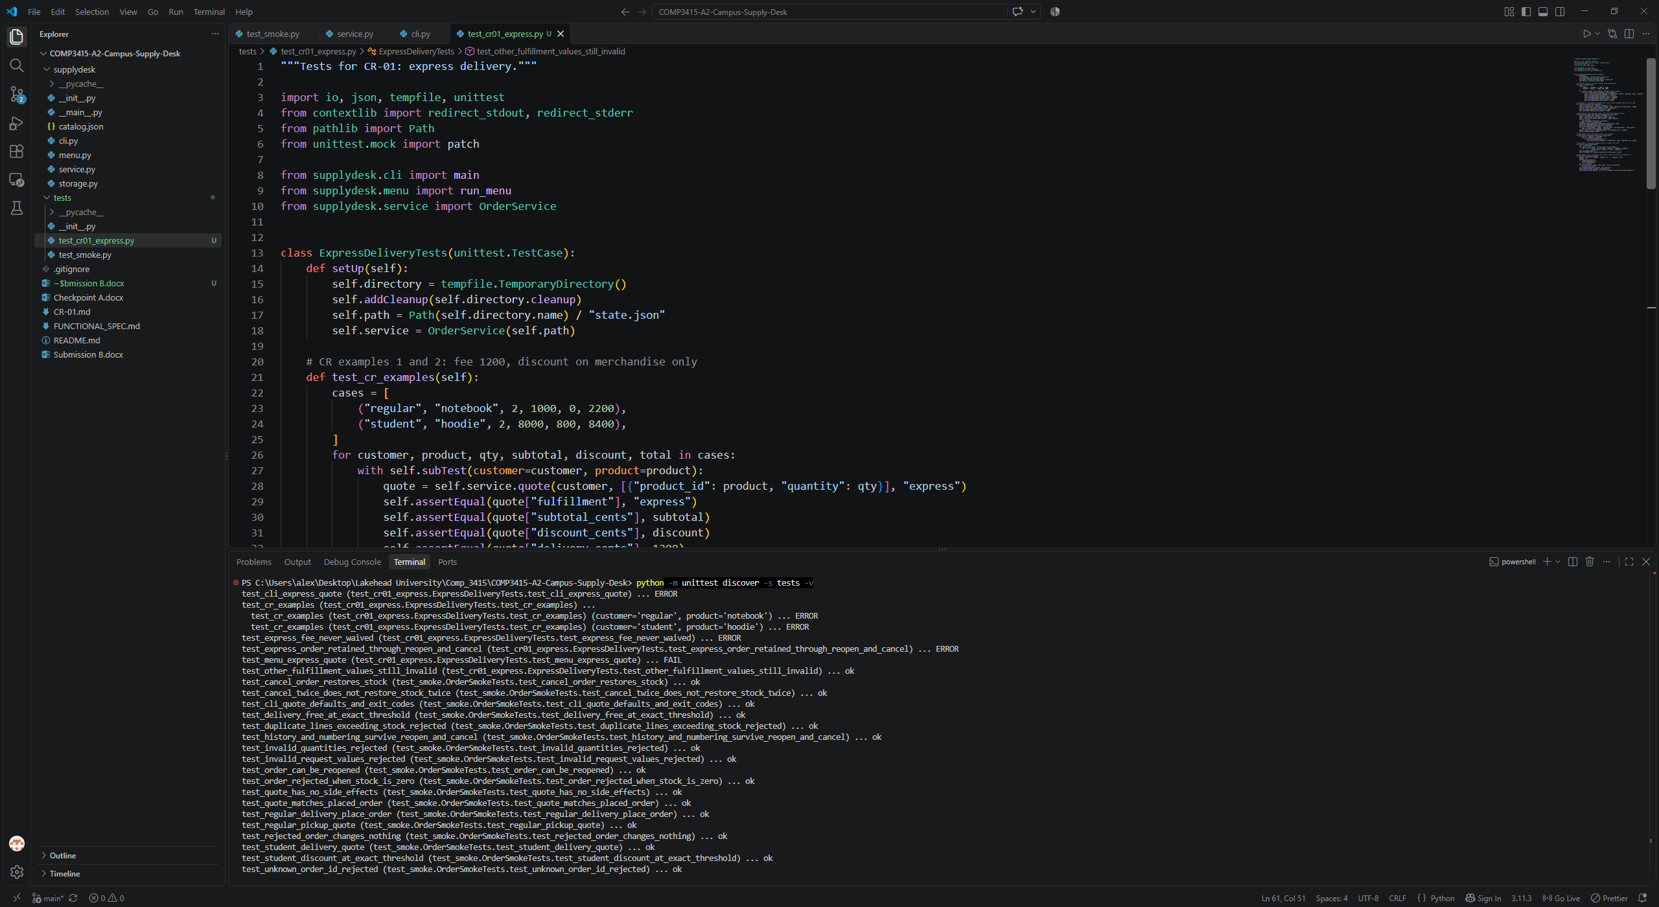
Test result after adding features, we can see all new 6 tests passed. And the quote is correct. We have also modified the cli.py, so now help message display express option for user.
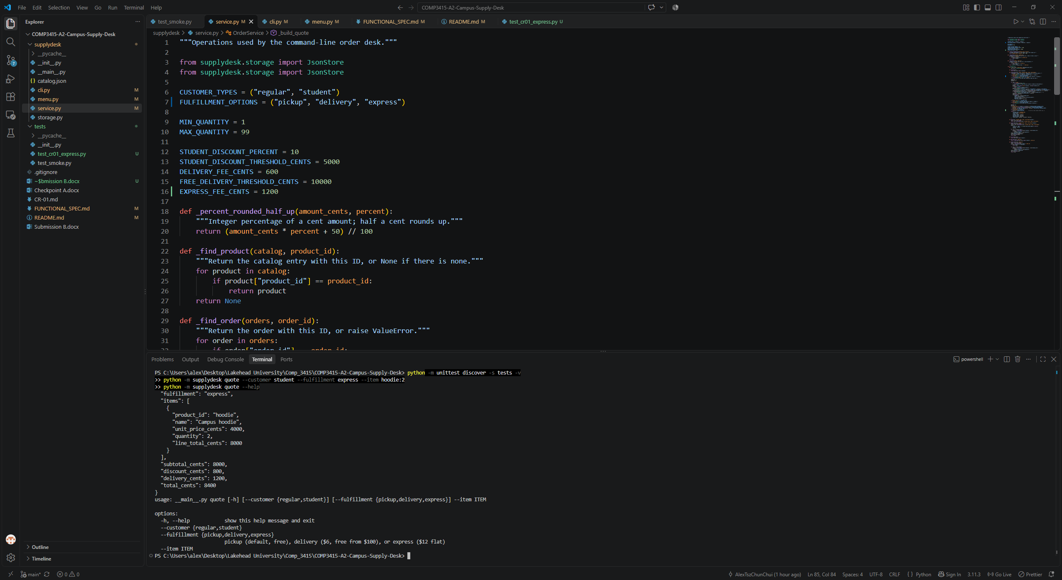
- Which files or methods actually changed
build_quote function, the named constant and the menu are changed.
- Whether your original prediction was correct
I did not expected to update the help message in cli.py and also I completely forgot to update readme and spec document before implementing the change.
- Which tests were added or updated
We created a new test file for this new added features, applying the TDD(Test driven development) concept and also to separate it from the basic test. New test included testing the express fees correctly applied, it never waived, other behaviour worked as usual before the new features implemented and also tested the menu.
- Whether your earlier refactoring made the change easier, harder, or had little effect.
The earlier refactoring help a lot since we extract magic value with named variables, we only have to change very few code to make the new logic run.

